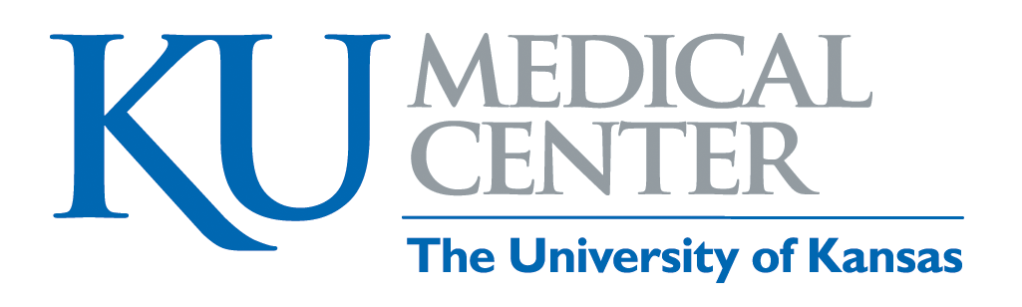
Return of Title IV Funds Calculation

These steps were followed in calculating the amount KUMC had to return on your behalf:
- Determine the percentage of the enrollment period completed by the student.
Days Attended ÷ Days in Enrollment Period = Percentage Completed
If the calculated percentage is more than 60%, then the student has “earned” all Title IV aid for the enrollment period.
- Apply the percentage completed to the Title IV aid awarded to determine the student’s eligibility for aid prior to the withdrawal.
Total Aid Disbursed x Percentage Completed = Earned Aid
- Determine the amount of unearned aid to be returned to the appropriate Title IV aid program.
Total Disbursed Aid – Earned Aid = Unearned Aid to be Returned
If the aid already disbursed equals the earned aid, no further action is required.
If the aid already disbursed is less than the earned aid, the student will be contacted to determine if the student would like the aid to be canceled, or if the student would like a late disbursement. Late disbursements will be made for students needing the funds for education expenses.
If the aid already disbursed is greater than the earned aid, the difference must be returned to the appropriate Title IV aid program.
- Distribute the responsibility to return funds between the institution and the student.
Funds that KUMC must return: The student will receive a letter outlining the amount KUMC must return on the student’s behalf. The student will be expected to repay that amount to KUMC. Any amount that must be repaid to KUMC is due immediately. No grace period applies to this amount.
Funds that the student must return: If the type of aid that the student is responsible for returning is a loan, then the student is not required to immediately repay the amount as the grace period for that loan, generally six months, is invoked. If the type of aid that the student is responsible for returning is a grant, then the student will incur a charge on the University bill. Federal return of funds regulations require that the student only repay one-half of the grant amount that is unearned.
Any refund or repayment obligation will be clearly outlined for the student in writing and will also appear on their University bill.
- Return the Title IV aid, based on the type of aid disbursed, in the following order:
  - Unsubsidized Direct Loan
  - Subsidized Direct Stafford Loan
  - Federal Perkins Loan
  - Federal Direct PLUS Loan (Graduate)
  - Federal Direct PLUS Loan (Parent)
  - Federal Pell Grant
  - Federal SEOG

